- What is Recursion?
Recursion is a programming technique in which a function or method calls itself to solve a problem. Instead of solving the entire problem at once, recursion breaks it down into smaller, similar subproblems until a simple condition (called the base case) is reached.
A recursive algorithm has two parts:
- Base Case – Stops the recursion.
- Recursive Case – Calls itself with a smaller input.
Recursion simplifies problems by breaking a large problem into smaller, similar subproblems. Instead of writing complex loops and maintaining multiple variables, a recursive function repeatedly solves a smaller version of the same problem until it reaches a simple base case.
2. Setup: Create a Method to Calculate the Future Value Using a Recursive Approach
In financial forecasting, the future value can be calculated using compound growth.
Recursive Method:
public static double futureValue(double presentValue,
double growthRate,
int years) {
if (years == 0) {
return presentValue;
}
return futureValue(presentValue,
growthRate,
years - 1)
* (1 + growthRate);
}

3)Implementation:
  - Implement a recursive algorithm to predict future values based on past growth rates.
FinancialForecast.java
public class FinancialForecast {
public static double futureValue(double presentValue,
double growthRate,
int years) {
if (years == 0) {
return presentValue;
}
return futureValue(presentValue,
growthRate,
years - 1)
* (1 + growthRate);
}

public static void main(String[] args) {
double presentValue = 10000;
double growthRate = 0.10; // 10%
int years = 5;
double forecast = futureValue( presentValue, growthRate, years);
System.out.println("===== Financial Forecast =====");
System.out.println("Present Value : " + presentValue);
System.out.println("Growth Rate : " + (growthRate * 100) + "%");
System.out.println("Years : " + years);
System.out.println("Future Value : " + forecast);
}
}

OUTPUTS:
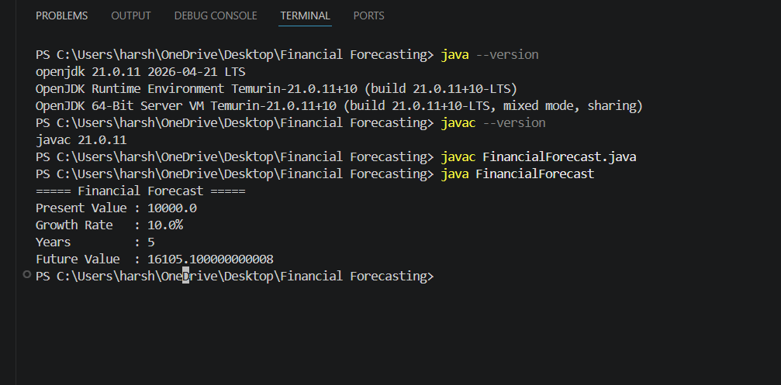

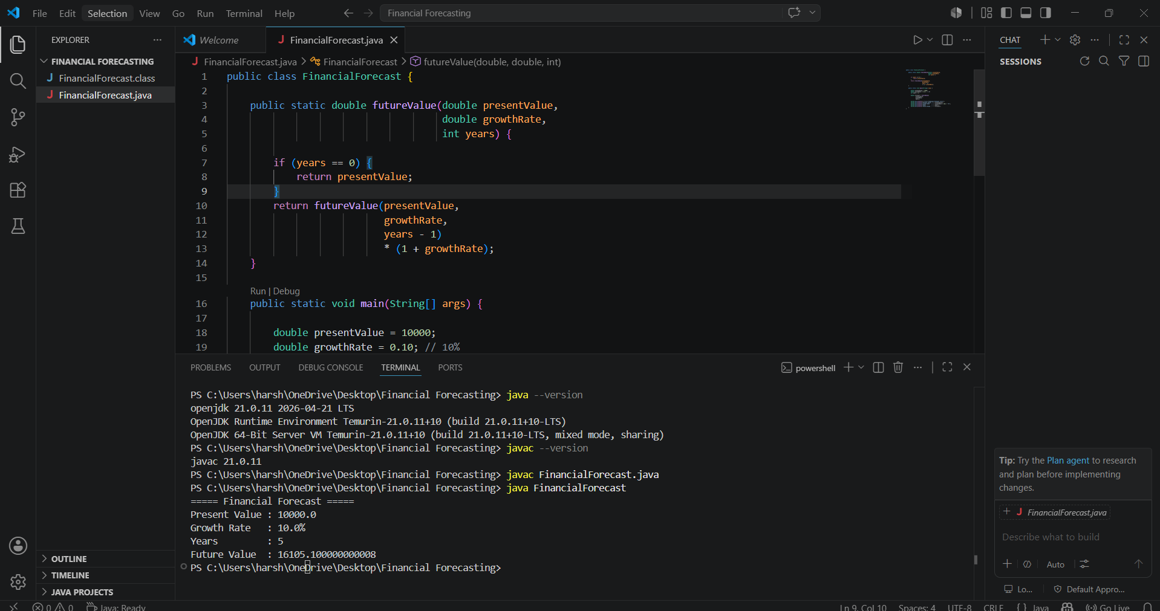

- Analysis:
Discuss the time complexity of your recursive algorithm.
Explain how to optimize the recursive solution to avoid excessive computation.
The recursive forecasting algorithm has a time complexity of O(n) and a space complexity of O(n) because one recursive call is made for each year. To avoid excessive computation and memory usage, the solution can be optimized using an iterative approach (O(1) space) or fast exponentiation (O(log n) time), which is the most efficient method for large forecasting periods.
Method | Time Complexity | Space Complexity
Recursive | O(n) | O(n)
Iterative | O(n) | O(1)
Fast Exponentiation | O(log n) | O(log n)

Recurrence Relation
For each year, the method makes one recursive call:

T(n) = T(n - 1) + O(1)

where:
- T(n) = time required for n years
- O(1) = multiplication operation

Time Complexity : T(n) = O(n)
Space Complexity : O(n)

